|  |
| --- |
| **GROWING UP ONLINE** |

<http://www.pbs.org/wgbh/pages/frontline/kidsonline>

|  |
| --- |
| **TEXT** |

**January 22, 2008**

FRONTLINE takes viewers inside the private worlds that kids are creating online, raising important questions about how the Internet is transforming the experience of adolescence. At school, teachers are trying to figure out how to reach a generation that no longer reads books or newspapers. Fear of online predators has led teachers and parents to focus primarily on keeping kids safe online. But many young people think these fears are misplaced. Online media has also intensified the social dimensions of adolescence as teens create and play with identities on sites like MySpace and Facebook and encounter intense peer pressure in a variety of virtual worlds. Parents are confused about how to respond to the increasingly private worlds inhabited by their children, lacking an understanding of both the creative potential and the genuine risks of this new dimension of our cultural environment.

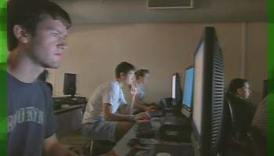

Jessica Hunter was a shy and awkward girl who struggled to make friends at school. Then, at age 14, she reinvented herself online as Autumn Edows, a goth artist and model. She posted provocative photos of herself on the Web and fast developed a cult following.

"I just became this whole different person," Autumn tells FRONTLINE. "I didn't feel like myself, but I liked the fact that I didn't feel like myself. I felt like someone completely different. I felt like I was famous."

News of Jessica's growing fame as Autumn Edows reached her parents only by accident. "I got a phone call, and the principal says one of the parents had seen disturbing photographs and material of Jessica," her father tells FRONTLINE. "I had no idea what she was doing on the Internet. That was a big surprise."

In *Growing Up Online*, FRONTLINE takes viewers inside the very public private worlds that kids are creating online, raising important questions about how the Internet is transforming childhood. "The Internet and the digital world was something that belonged to adults, and now it's something that really is the province of teenagers, " says C.J. Pascoe, a postdoctoral scholar with the University of California, Berkeley's Digital Youth Research project.

"They're able to have a private space, even while they're still at home. They're able to communicate with their friends and have an entire social life outside of the purview of their parents, without actually having to leave the house."

As more and more kids grow up online, parents are finding themselves on the outside looking in. "I remember being 11; I remember being 13; I remember being 16, and I remember having secrets," mother of four Evan Skinner says. "But it's really hard when it's the other side."

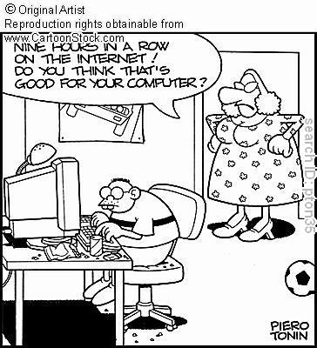At school, teachers are trying to figure out how to reach a generation that no longer reads books or newspapers. "We can't possibly expect the learner of today to be engrossed by someone who speaks in a monotone voice with a piece of chalk in their hand," one school principal says.

"We almost have to be entertainers," social studies teacher Steve Maher tells FRONTLINE. "They consume so much media. We have to cut through that cloud of information around them, cut through that media, and capture their attention."

Fears of online predators have led teachers and parents to focus heavily on keeping kids safe online. But many

children think these fears are misplaced. "My parents don't understand that I've spent pretty much since second grade online," one ninth-grader says. "I know what to avoid."

Many Internet experts agree with the kids. "Everyone is panicking about sexual predators online. That's what parents are afraid of; that's what parents are paying attention to," says Parry Aftab, an Internet security expert and executive director of WiredSafety.org. But the real concern, she says, is the trouble that kids might get into on their own. Through social networking and other Web sites, kids with eating disorders share tips about staying thin, and depressed kids can share information about the best ways to commit suicide.

Another threat is "cyberbullying," as schoolyard taunts, insults and rumors find their way online. John Halligan's son Ryan was bullied for months at school and online before he ultimately hanged himself in October 2003. "I clearly made a mistake putting that computer in his room. I allowed the computer to become too much of his life," Halligan tells FRONTLINE. "The computer and the Internet were not the cause of my son's suicide, but I believe they helped amplify and accelerate the hurt and the pain that he was trying to deal with that started in person, in the real world."

"You have a generation faced with a society with fundamentally different properties, thanks to the Internet," says Danah Boyd, a fellow at Harvard's Berkman Center for Internet & Society. "It's a question for us of how we teach ourselves and our children to live in a society where these properties are fundamentally a way of life. This is public life today."

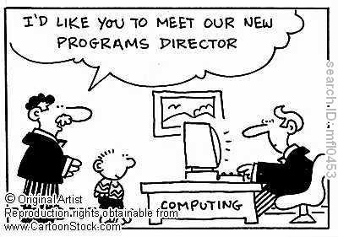

**Vocabulary**

Match the words in italics with the correct description

1. online *predators* 🡪 C

2. the *genuine* risks of this new dimension 🡪 E

3. a shy and *awkward* girl 🡪 A

4. *provocative* photos 🡪 I

5. the *province* of teenagers 🡪 F

6. the *purview* of their parents 🡪 B

7. to be *engrossed* by someone 🡪 G

8. schoolyard *taunts* 🡪 D

9. *to amplify* the pain 🡪 H

a. embarrassed or nervous

b. the limit of someone's responsibility, interest or activity

c. DISAPPROVING someone who follows people in order to harm them or commit a crime against them

d. remarks or jokes intended to hurt someone’s feelings or make him angry

e. real and exactly what it appears to be

f. a subject or activity of special interest, knowledge or responsibility

g. giving all your attention to something; absorbed

h. FORMAL to increase the size or effect of something

i. causing thought about interesting subjects

**Comprehension**

1. To what extent/in which way have online media changed the life of youngsters?

*Thanks to online media, youngsters are now able to communicate with their peers from virtually anywhere using social networks, forums, blogs, and so on. It is a “lawless” medium where you can pretend who you are, what you do and what you want, which appeals to a lot of young persons.*

2. How do parents and teachers feel about/cope with these changes?

*Most parents feel as if they’re trying to decipher a black box. Not only do they often lack the skills for monitoring their youngsters’ activities, they also don’t know how to react to this increasingly “publicly private” zone. They are mainly afraid of sexual predators stalking their children and e-bullying.*

3. What is the story of Jessica Hunter about?

*Jessica Hunter, aged 14, created an internet persona to make herself feel more accepted into a group: in this case, horny peers that loved her photographs. Her parents eventually discovered this, which undoubtedly made for a lot of drama.*

4. Explain: “Internet and the digital world … is now something that really is the province of teenagers.”

*As described before, it is mainly youngsters that trawl the internet looking around for interesting or funny things to do. Adult either do not have the time or the skills required to create another reality; they’re already busy enough in the real one.*

5. What are the different threats of online media?

*- Sexual predators*

*- E-bullying*

*- The veil of anonymity that can quickly disappear*

|  |
| --- |
| **VIDEO** |

<http://www.pbs.org/wgbh/pages/frontline/kidsonline/view/main.html>

**Chapter 1: Living their lives essentially online**

In Morris County New Jersey, as in the rest of the U.S., 90% of teens are online, immersed in a virtual world that’s largely hidden from their parents.

**Chapter 2: A revolution in classrooms and social life**

As teachers are figuring out if the old rules still apply, at home, kids are socializing at digital hang outs like MySpace and Facebook.

**Chapter 3: Self-expression, trying on new identities 🡨 View this one**

Jessica Long felt shy and awkward. But she’s reborn online as goth artist and model Autumn Edows and finds fame, adulation and hundreds of friends.

**Chapter 4: The child predator fear**

Media coverage of predators has been building the past year. But researchers in a Justice Dept.-funded study found the threat has been exaggerated.

**Assignments**

**Speaking**

Watch 1 of the four chapters at home (the chapter you are expected to watch will be indicated in class) and take note of the central ideas. In class you get 5 minutes to tell the others what your chapter is about. For this exercise you can use your notes.

**Writing**

With the help of the notes you made (cf. assignment above) write a fluent and coherent 25-line summary of your chapter.

|  |
| --- |
| **SHARE YOUR THOUGHTS** |

Dear FRONTLINE,

I am a 19-year-old college student. I first got an AIM Screen name when I was 11. By the time I was 14, I had gone through 5 different names because I wanted to change my persona. Also, at 14, I had first created my page on MySpace. Now, I maintain a Facebook account. I am a definite product of the cyber age.

I have mixed feelings about this program because, though it did address social networking sites such as Facebook and MySpace, it did not address a major part of the latter: blogs.

A major criticism that I have of the program is that it still seemed like fear-mongering. I didn't think that enough was said about the positive aspects of being online. For example, I have done research for a term paper on blogging. One thing that is important to recognize is that blogs are journals. Psychologists have stated that journaling can be therapeutic, and thus writing in a blog can be just as therapeutic.

Overall, I feel that the program was great. I appreciate the fact that Frontline is choosing to cover a topic that will definitely be looked at for years to come. The Internet is not going away. Now, it is necessary for people to look back and determine the consequences that modern technology will have for future generations.

Bob Kasper, Frankfort, Illinois

More opinions on <http://www.pbs.org/wgbh/pages/frontline/kidsonline/talk>

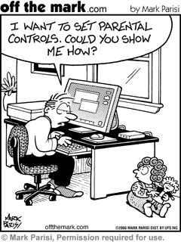

**Assignment**

How do you view the Internet’s impact on youngsters? Do you worry about it or not? And do you have a story to share? Formulate your opinion on the topic/video and your experiences in a 10-15 line letter to Frontline.

*The exposure of the current and future generations of youngsters will be a very interesting sight to see, even more than it is now. Currently, youngsters have created a private space that can be accessed publicly, which allows them to stay in touch with virtually anyone, anywhere, at any time. It certainly gives them a lot more power and control over their personal lives than before. In fact, it’s become a true extension of their world. “Real” and “virtual” reality no longer exist: Augmented Reality would be a better term. Want to check if there’s a party tonight and who’s coming? Check your Facebook or MySpace. Want to hear the latest rumours? Check Twitter. Just want to have a simple conversation with someone? Private messengers and chat rooms are still around aswell.*

*The biggest danger about these new online media is that even youngsters don’t learn all the threats quickly enough. E-bullying, stalking and identity theft or falsification are common issues that are not overcome so easily.*

**Discussion**

1. Describe your use of the online media:

- surfing, chatting, e-mailing, social networking sites, blogs, YouTube, posting pictures, …

- frequency, amount of time spent on it

Can you imagine a life without the internet?

How has the internet transformed your experience of adolescence?

Do you encounter peer pressure in the virtual world?

Are you part of “a generation that no longer reads books or newspapers”?

Do you behave differently on the net than in real life? (use of language, online identity – actual identity)

2.. How do your parents cope with your online life? Are they “on the outside looking in”?

And what about school/teachers?

3. What about safety online: online predators, cyberbullying, websites about eating disorders/committing suicide, …?